Okeke, Uche (1933 - )
Born as Christopher Uchefuna Okeke in Anambra State, Nigeria in 1933, Uche Okeke is a founding father of Nigerian Modern Art. As one of the original members of the Zaria Art Society and the author of the group’s manifesto, which laid out the principles of Natural Synthesis, Okeke was influential in the formation of a national aesthetic both as an artist, a writer, poet, playwright, and as a teacher. Okeke sought to bring together forms and subjects indigenous to his Igbo ethnicity with modern, foreign influences and techniques. He practiced primarily in pen and ink and oil painting, exploring Igbo folklore and a body and wall painting tradition called Uli. After graduating from the University of Nigeria in Zaria, Okeke actively promoted cultural activities throughout the country, running the Mbari Centre Workshops in Enugu and founding the Asele Institute which provided studio space, educational programming and a gallery for artists. Okeke was also influential on subsequent generations of Nigerian artists through his teaching at the University of Nsukka during the seventies. Additionally, he served as an ambassador for the art and culture of Nigeria for UNESCO, helping to promote Nigerian arts throughout the world.
Although the work done by members of the Zaria Art Society varied greatly, all members were engaged with the same effort to discover a true, modern Nigerian art, a quest fuelled by the euphoric drive towards independence in the late 1950s.

For Uche Okeke, uli body and wall decoration served not only as a referent to the artistic and cultural heritage of the Igbo people, particularly the women who practiced uli, but also a link to his personal past through his mother, who taught him the uli forms and techniques. While he became fluent in the visual language of uli through his mother’s teaching, Okeke also thoroughly researched the tradition through materials he found in museums and libraries, becoming well informed on the history of the tradition and artistically confident through these processes. He read the novels of Amos Tutuola and Chinua Achebe, gaining a deeper understanding of the Igbo culture through Achebe’s Things Fall Apart (1958). He would later go on to collaborate with Achebe with an illustrated version of his novel. His newfound cultural awareness along with a confidence in drawing and fluency in the pictorial language of uli would prove useful during his sojourn in Munich in 1962 where Okeke trained in mosaic and stained glass techniques.

These confidences also helped move his work from the figurative painting he began with at Zaria, such as Christ of 1961, to more abstract painting using uli forms, to the fluid, line-based drawings that became his signature medium and style, such as in Onalu. This line drawing references the legendary beauty from an Igbo folktale, portrayed with signature marks of beauty and admiring her reflection in a mirror. With these linear compositions, Okeke’s work became increasingly lyrical in style and frequently, though subtly, political in content, using traditional forms as a way of progressing forward, not looking backward to the past.

The self-directed education Okeke provided himself was a direct response to the arts education he and his Art Society colleagues were receiving at Zaria, which they believed was too foreign oriented. Out of all the lecturers in the Zaria Fine Art Department, only one was Nigerian, and all were trained in London. It was not an all-out rejection of their education, but rather a call for that education to be reevaluated and its curriculum balanced with methods, techniques and substance that related to local culture and history, and instructors who were well versed in them. Thus, what Okeke derived from Uli, Nwoko and Bruce Onobrakpeya sought from other indigenous art forms, including Yoruba textiles, Nok terracotta sculptures, and Urhobo folklore. Upon graduation, the group dispersed but Okeke and Nwoko would work together again later at the Mbari Mbayo workshops led by Ulli Beier.
Okeke’s impact on the development of Nigerian Modern art extends through several generations of artists working far beyond Zaria. In particular, Okeke’s writings on Natural Synthesis and his work with uli were highly influential on the work of Obiora Udechukwu, and later Tayo Adenaike, both of whom trained under Okeke at the University of Nsukka, where he held the position of the Director of the Visual Art Department, and helped form what would come to be known as the Nsukka School during the 1970s.

List of Works:
Okeke, U. (1961) Drawings, Ibadan: Mbari.
Okeke, U. (1960) “Natural Synthesis” Zaria. Reprinted in Seven Stories about Modern Art in Africa (see below).
Okeke, U. (1972) “Ekeama” African Arts, Vol 5 No. 2 1972
Okeke, U., L. G. Lambert (1982) Art in Development: A Nigerian Perspective, Asele Institute.

References and Further Reading
Chukueggu, Chinedu C. (2010) “The Asele Period in Uche Okeke’s Creativity 1958-1966” African Research Review 4 (3a): 261-275.
Enwezor, Okwui (ed.) The Short Century: Independence and Liberation Movements in Africa 1945-1994, Munich: Prestel.
Kasfir, S. L. (2000) Contemporary African Art, New York: Thames and Hudson.
Okeke, C. (1995) “The Quest: from Zaria to Nsukka” in Seven Stories about Modern Art in Africa. Ed. Clementine Deliss, Flammarion: Paris.
Okeke-Agulu, C. (2006) “Nationalism and the Rhetoric of Modernism in Nigeria: The Art of Uche Okeke and Demas Nwoko, 1960-1968” African Arts, 39 (1): 26-37.
Onobrakpeya, B. (1995) “The Zaria Art Society” in Seven Stories about Modern Art in Africa. Ed. Clementine Deliss, Flammarion: Paris.

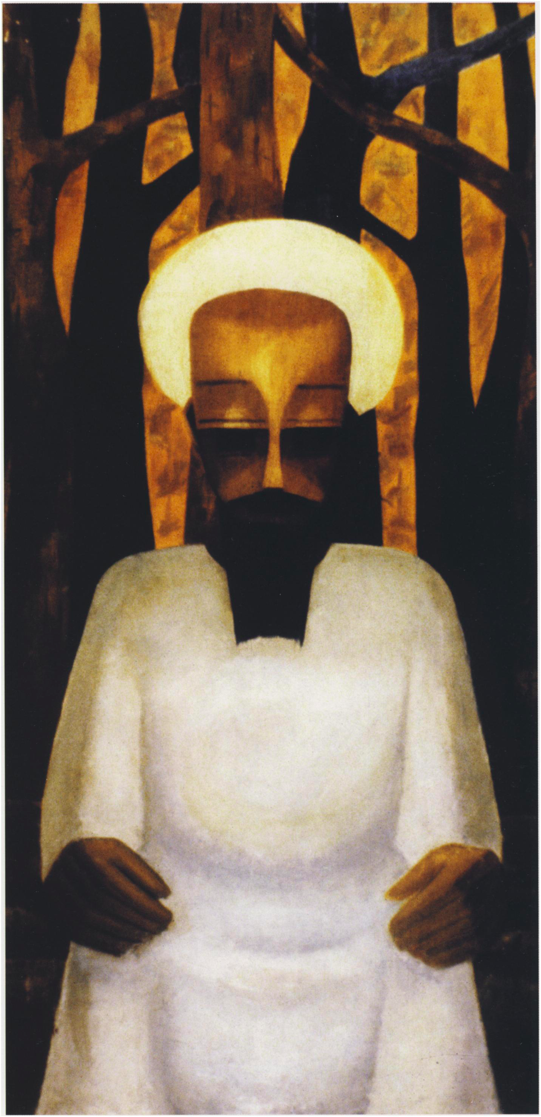
Uche Okeke, Christ, 1961, oil on board, 122 cm x 61 cm
Collection of Iwalewa-Haus, Bayreuth
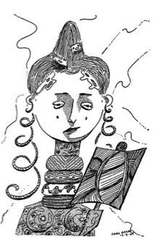
Uche Okeke, Onalu, 1958 pen and ink .
Probably in: Okeke, U. Drawings and Prints 1954-1972, Institute of African Studies, University of Nigeria, Nsukka (1972)

